TASK 1: How to setup Apache Server Step 1: Update the local package index Command:

Install the apache2 package:

Command:

Step 2: Configure The Firewall

Although the installation process for Apache is complete, there is one more extra phase. Configure the default UFW firewall to allow traffic on port 80.

Start by displaying available app profiles on UFW:

Command:

The terminal should respond by listing all available application profiles, as seen in the example below.
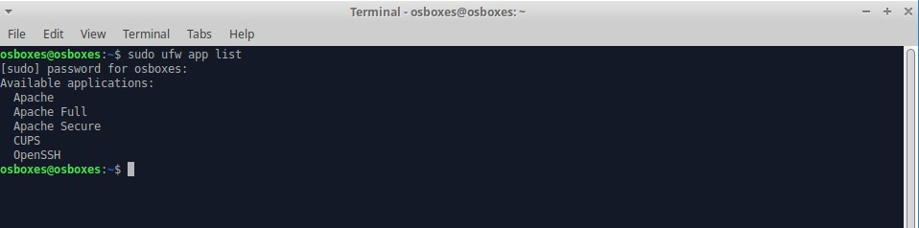

Let’s enable the most restrictive profile that will still allow the traffic you’ve configured, permitting traffic on port 80 (normal, unencrypted web traffic):

Command:

Verify the change:

In case your firewall’s status is inactive, you can use the command “sudo ufw enable” to active.

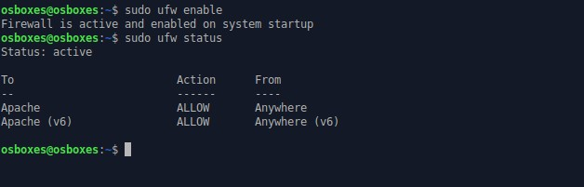

Step 3: Checking your Web Server

Check with the systemd init system to make sure the service is running by typing: Command:

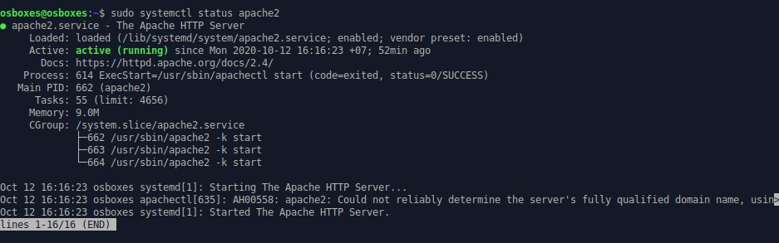

Access the default Apache landing page to confirm that the software is running properly through your IP address: http://your_server_ip

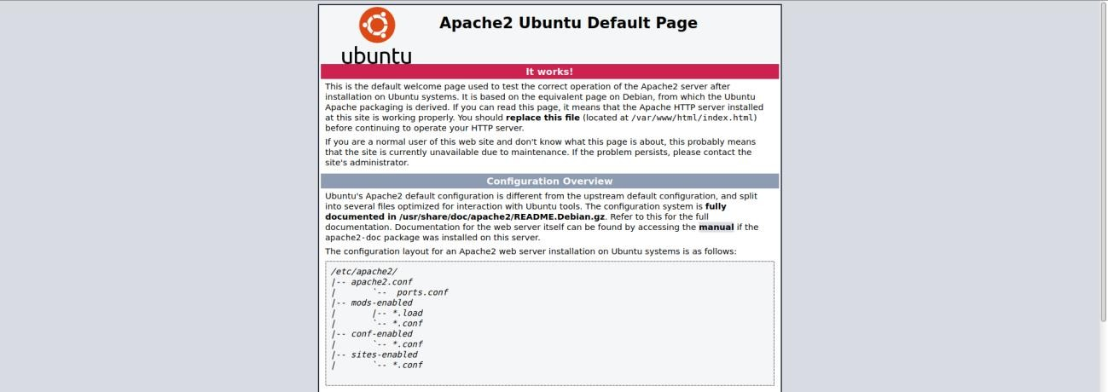

Step 4: Set up password Authentication

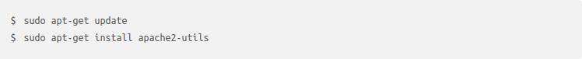
* Installing the Apache Utilities Package Command:

— Creating the Password File

We now have access to the htpasswd command. We can use this to create a password file that Apache can use to authenticate users. We will create a hidden file for this purpose called
.htpasswd within our /etc/apache2 configuration directory. The first time we use this utility, we need to add the -c option to create the specified file. We specify a username (jupyter in this example) at the end of the command to create a new entry within the file:
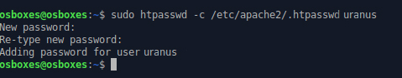

Leave out the -c argument for any additional users you wish to add:
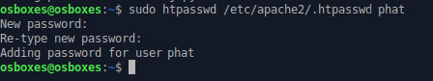

If we view the contents of the file, we can see the username and the encrypted password for each record:



STEP 5: — Configuring Apache Password Authentication Configuring Access Control within the Virtual Host Definition
Begin by opening up the virtual host file that you wish to add a restriction to. For our example, we’ll be using the 000-default.conf file that holds the default virtual host installed through Ubuntu’s apache package:

Authentication is done on a per-directory basis. To set up authentication, you will need to target the directory you wish to restrict with a <Directory > block. In our example, we’ll restrict the entire document root, but you can modify this listing to only target a specific directory within the web space.

Within this directory block, specify that we wish to set up Basic authentication. For the AuthName, choose a realm name that will be displayed to the user when prompting for credentials. Use the AuthUserFile directive to point Apache to the password file we created. Finally, we will require a valid-user to access this resource, which means anyone who can verify their identity with a password will be allowed in:

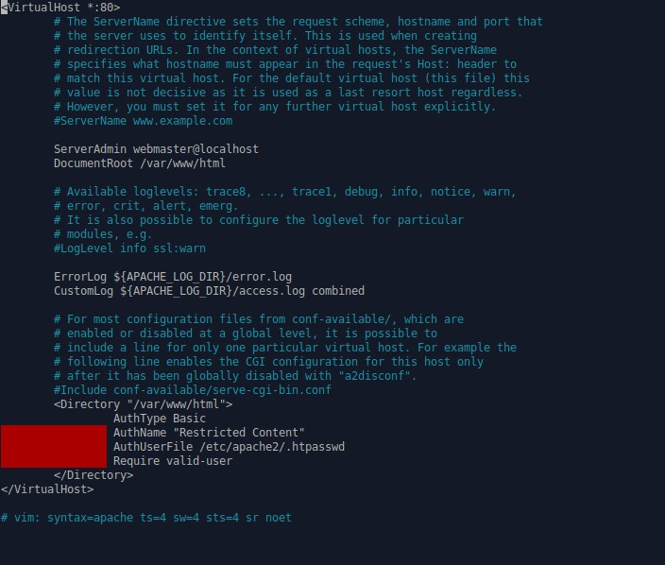

Save and close the file when you are finished.

Before restarting the web server, you can check the configuration with the following command: Command:

- Confirming Password Authentication
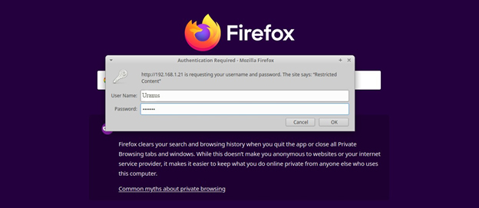

In case I type wrong password, I can not access to the web server:
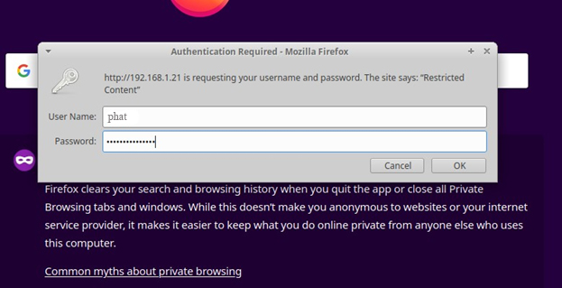

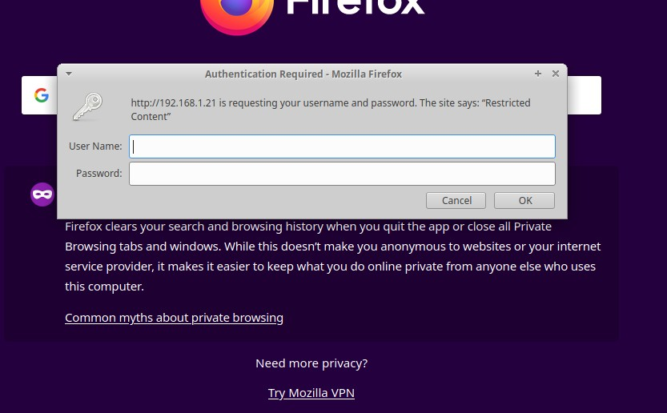

In case you want to see all the log files, this is the path: /var/log/apache2/. It contains all the process and action from user with the web server.
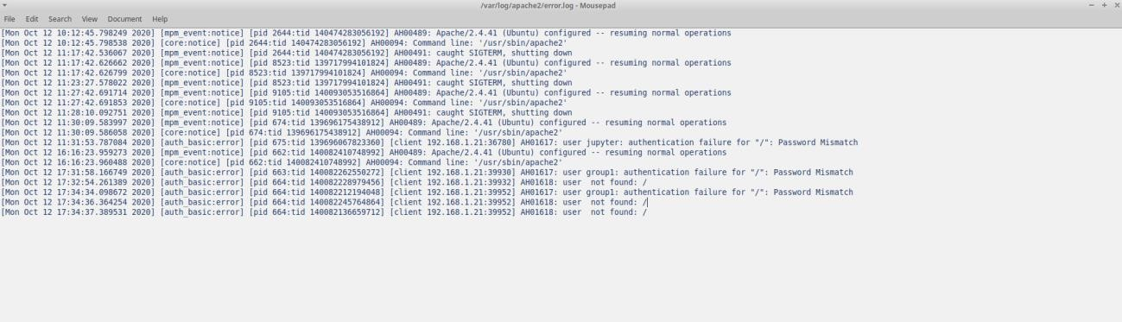

TASK 2: How to prevent access to file in a certain folder
Step 1: Create a “restricted” folder and a file in it
sudo mkdir /var/www/html/restricted
sudo touch /var/www/html/restricted/abc.html
Step 2: Configuring Access Control within the Virtual Host Definition
Instead of using a .htaccess file, it is usually preferred to place the configuration directly in your Apache.conf file as follow:
sudo nano /etc/apache2/apache2.conf
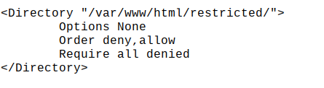
REFERENCES:

  - https://phoenixnap.com/kb/how-to-install-apache-web-server-on-ubuntu-18-04
  - https://www.digitalocean.com/community/tutorials/how-to-install-the-apache-web- server-on-ubuntu-18-04-quickstart
  - https://www.digitalocean.com/community/tutorials/how-to-set-up-password- authentication-with-apache-on-ubuntu-16-04
  - https://stackoverflow.com/questions/5046100/prevent-access-to-files-in-a-certain-folder

